**INFO 6250 - Web Development Tools & Methods – Final Report**

**Project Title:**

MoviesCorner – Find your next favorite

**Author:**

Bhavya Patel

(001351292)

**PROJECT SUMMARY**

MoviesCorner is an open movie community buff that allows users to read about their favorite movies, to add ratings about movies, to add movie into watchlist, to let review on movies. Also User can follow other users so that other user can see about each other watchlist, ratings, reviews, follow list. There are two kind of users such as User and Critic. Difference between User and Critic is that Critic has additional right such as he can add reviews to movies.

Movie details is fetched from the open source API of themoviedb.org. Popular movies, Now playing movies, movie basic details such as poster path, backdrop path, movie title, overview, runtime, genre, release date, cast details etc.

REST APIs for user watchlist, ratings, reviews, follow list are made in **Spring MVC** Rest Controller, **Hibernate** ORM, **MySQL** database. Each of the call to the end point returns JSON response along with HTTP status code.

Front-end is developed using **React** and **Redux**. Each endpoint of Spring MVC rest APIs are called using AJAX asynchronous call to display the JSON data. To make any changes in back-end, the respected APIs is called.

**FUNCTIONALITY**

1. **User Register**

* Allows user to register using username, password, first name, last name and two kind of user role such as User and critics
* Returns JWT token after successful registration
* Form validator is used to validates the fields.

1. **User Login**

* Returns JWT token after successful login
* Form validator is used to validates the fields.

1. **Get User details**

* JWT token which is returned after successful login and registration is passed as a header to this end-point.
* Returns user details after validating JWT token

1. **Search Users**

* JWT token which is returned after successful login and registration is passed as a header to this end-point.
* Returns user details after validating JWT token

1. **Bcrypt password store**
   * Password is stored using bcrypt encryption in database so that other unauthorized person can no see the password.
2. **JSON Web Tokens(JWT) token generation:**

* To allow user to access routes in secure manner JSON Web Token is generated for each user and is sent as a x-auth-token header in request calling.
* Filter is used to validate tokens and redirect the reponse accordingly to the controllers and user.

1. **User follow, unfollow, following list, follower list:**

* JWT token is passed as a header while performing follow, unfollow in order to authorized user to access such functionality.
* Following list and follower list is return for particular user in term of requesting user point of view whether that user is following other user or not.

1. **Watchlist**
   * Allows user add movie to watchlist and remove movie from watchlist
   * User can see other users watchlist
2. **Ratings**
   * Users can give ratings to movie out of 10.
   * Average ratings for each movie is calculated at a time of requesting movie details.
   * User can also update, delete ratings.
   * Other user can see the ratings for the user.
3. **Reviews**
   * It lets Critic users to give reviews on movies.
   * User can delete reviews and other User can view the ratings for movie.
4. **Error controller**
   * In case of page not found or Method not allowed, JSON response is returned along with HTTP status code 404 and 405.
5. **Token not valid**
   * If there is some unauthorized access to APIs then “Token is not valid” response is returned along HTTP status code 400 and prevents user to perform such action.

**SCREENSHOTS**

**Home Screen**



**Login Page**

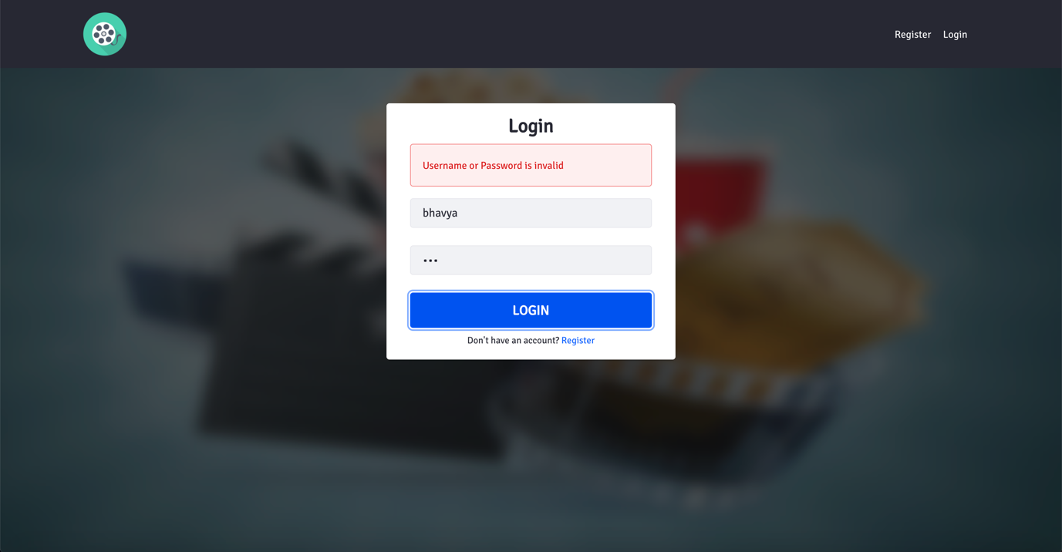

**Register Page with User already exists**

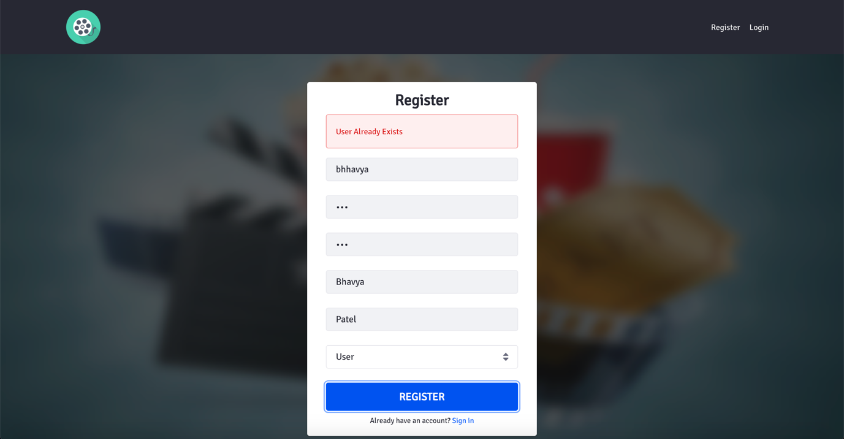

**Register Page with validating fields**

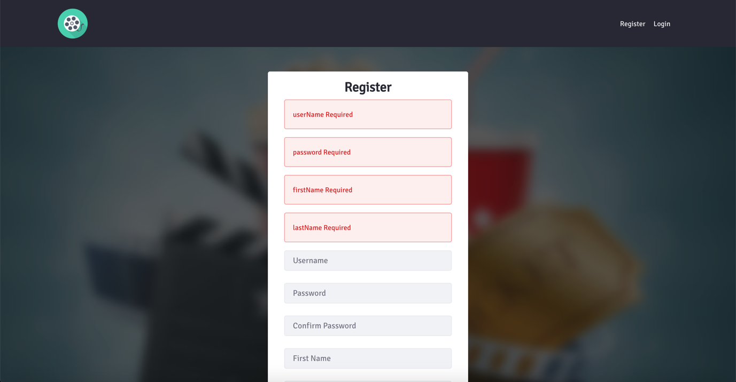

**Landing page with user detail in navigation**

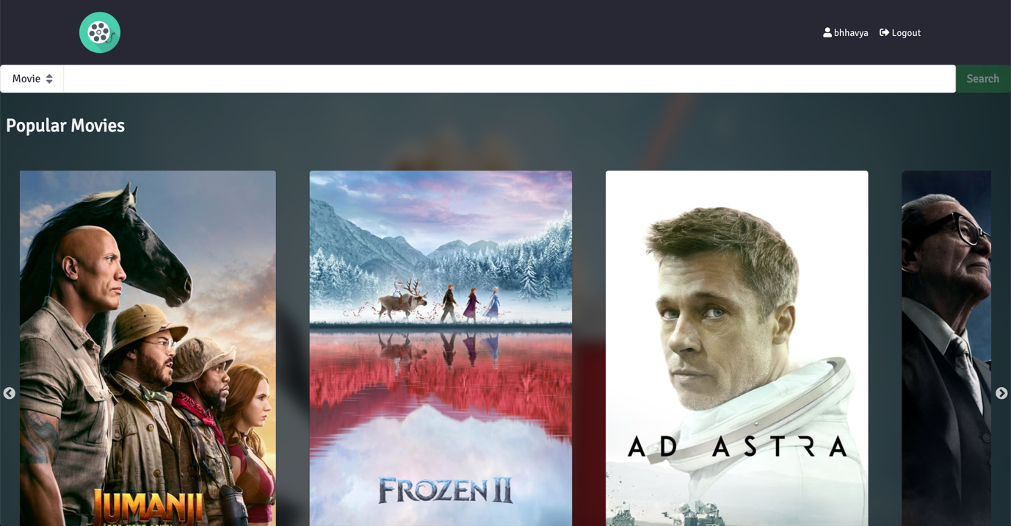

**Movie search result**

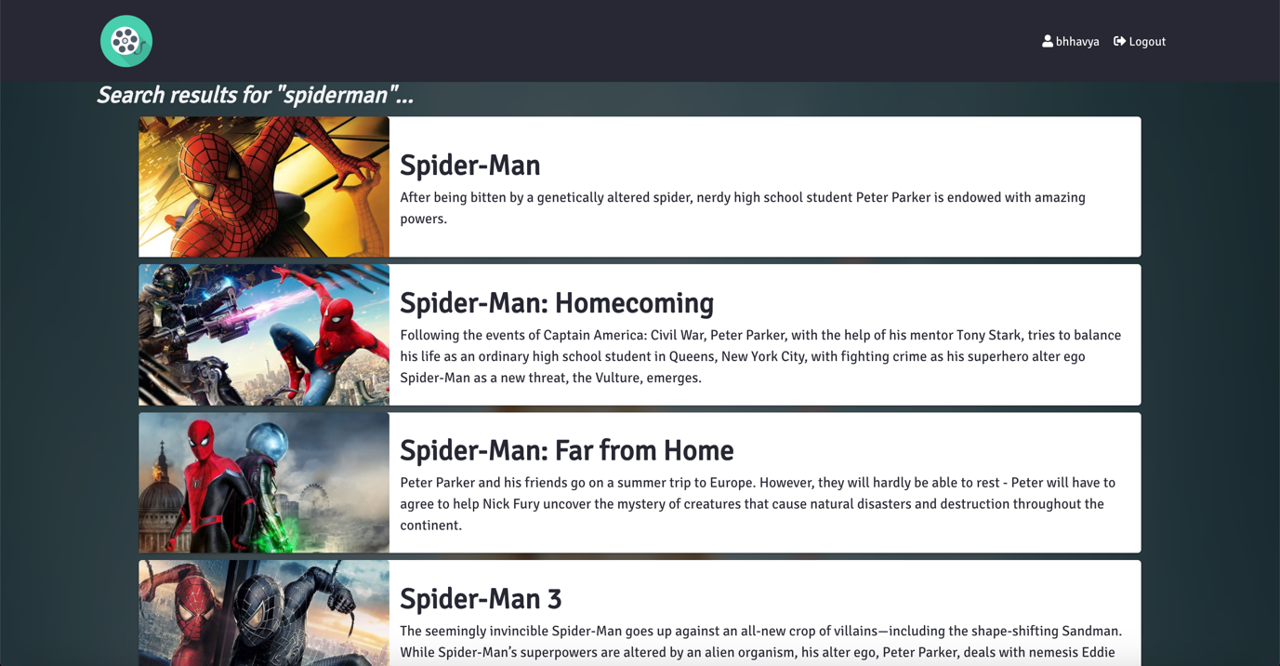

**Movie page without adding to watchlist**



**Movie page with remove from watchlist**

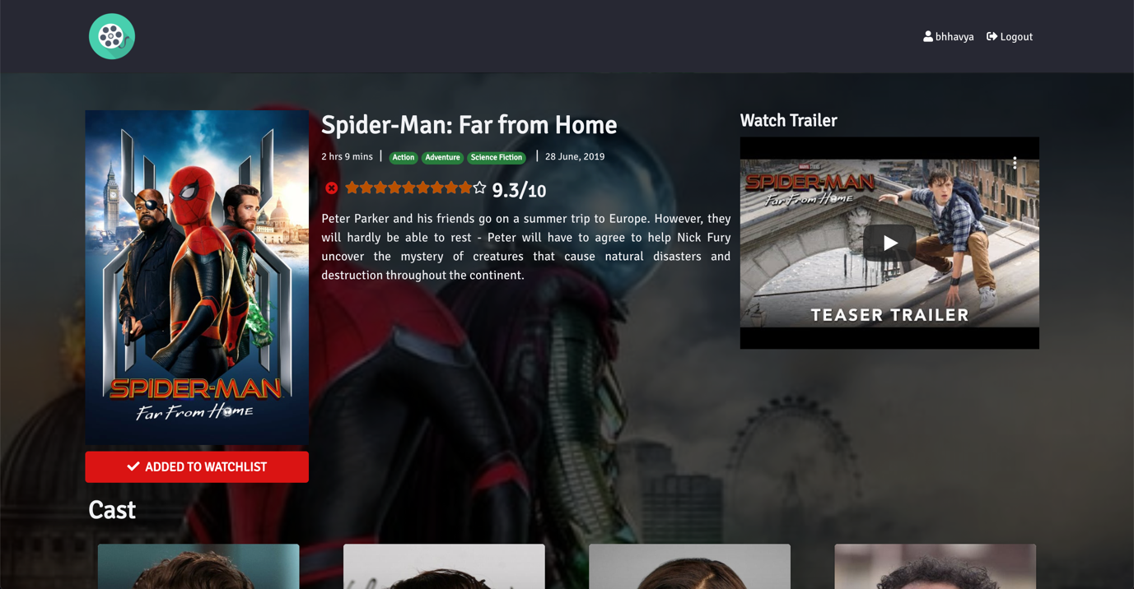

**User with User right can not give review on movie**



**Movie reviews**

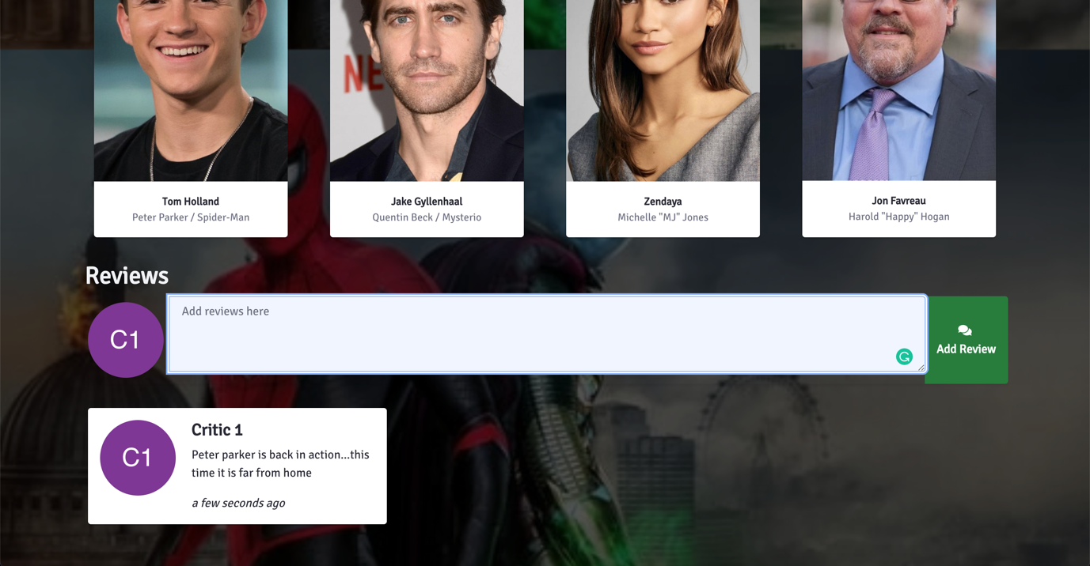

**Review list for user**

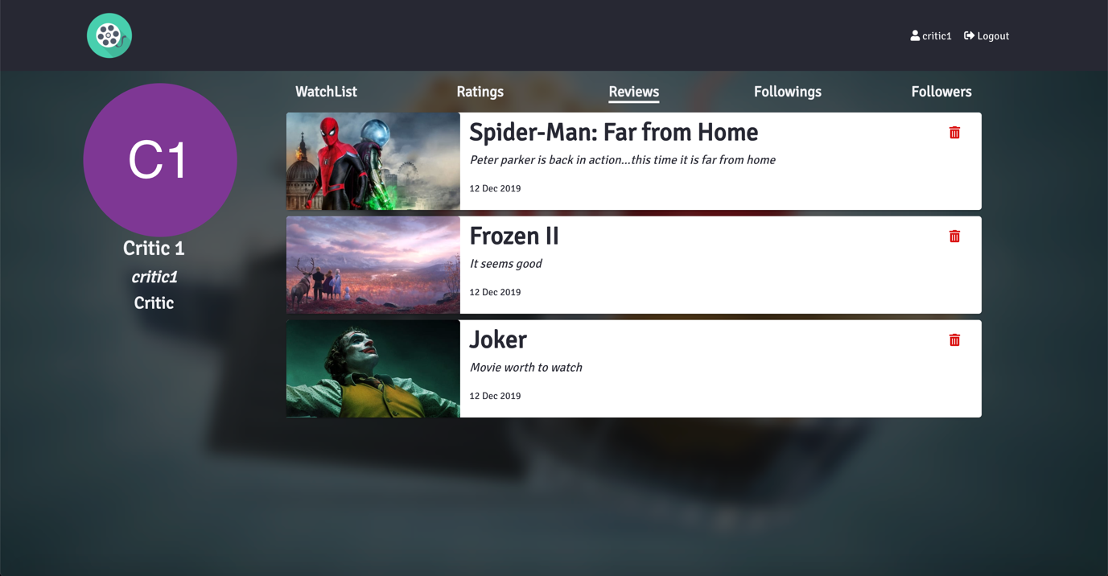

**Review list for user after removing review**

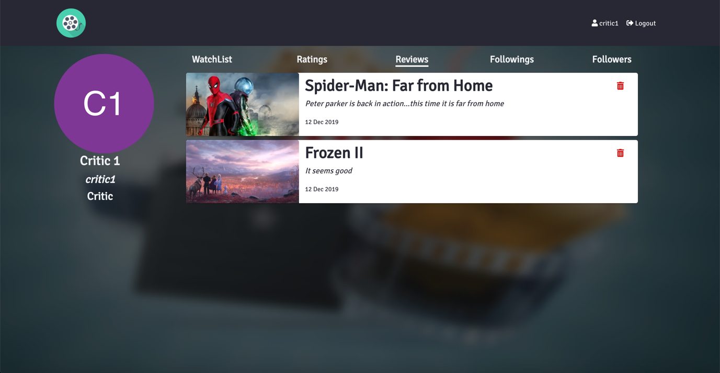

**Watchlist list for user**

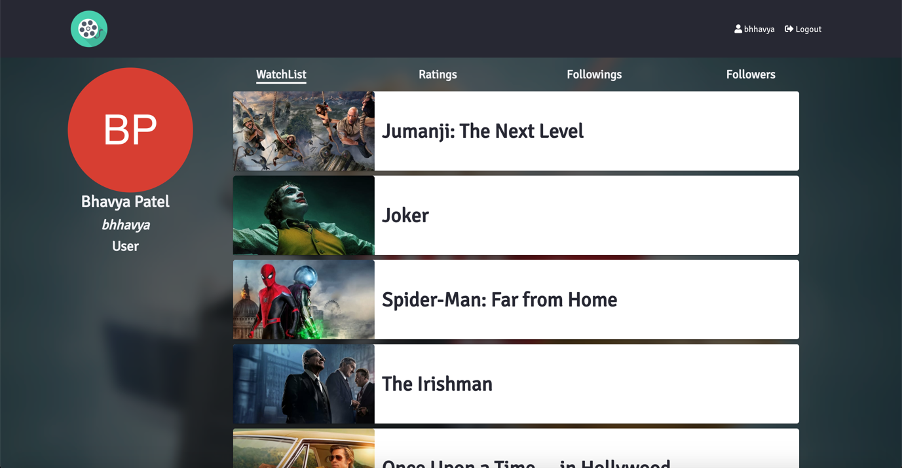

**Ratings list for user**

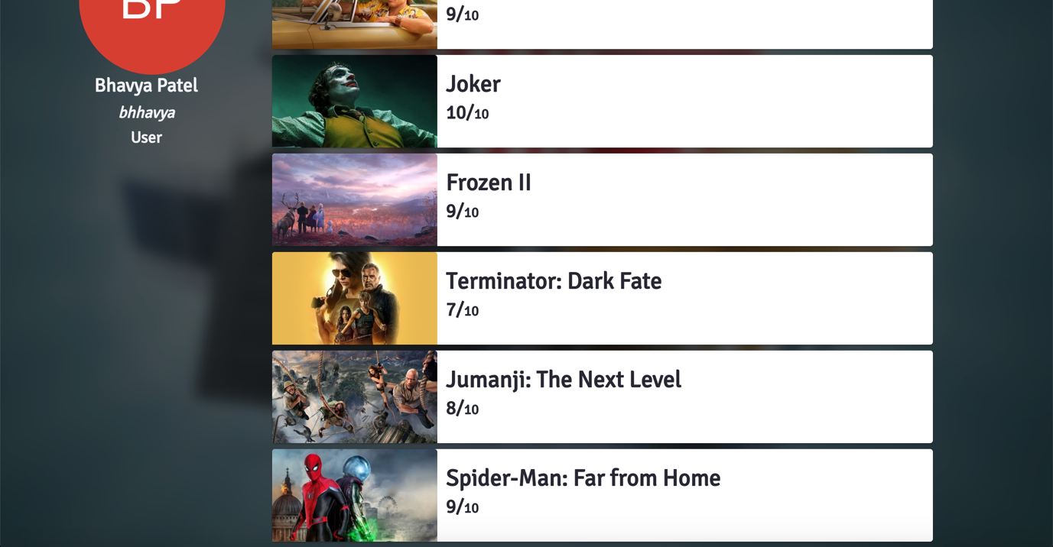

**User followers list for user**

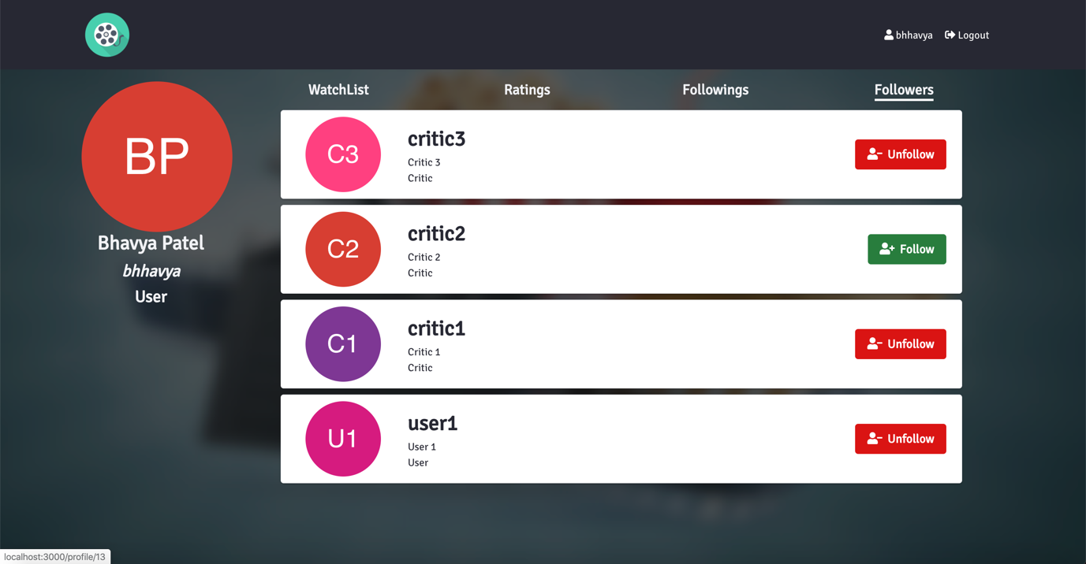

**User followings list for user**

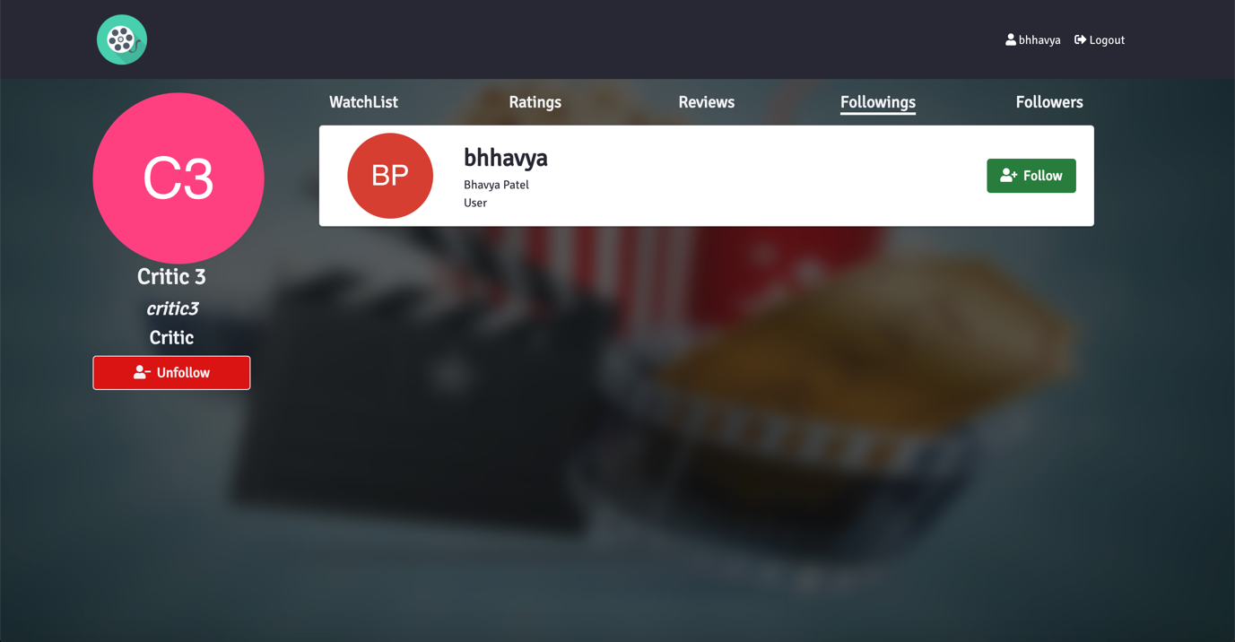

**User after unfollowing user**

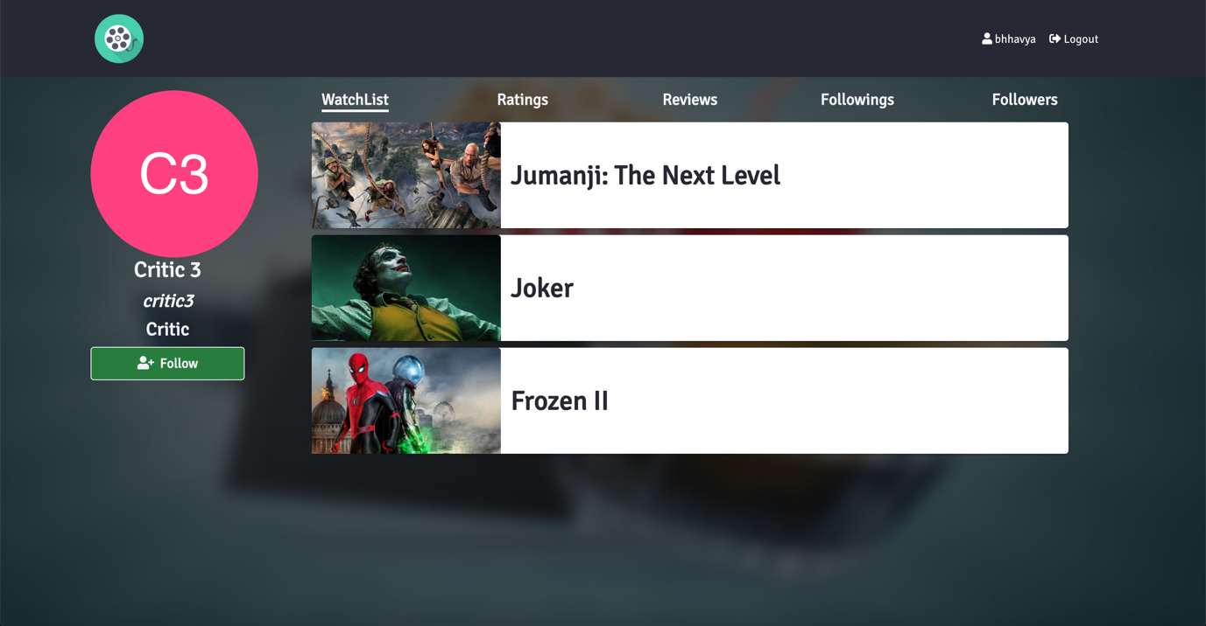

**Followings list after unfollowing user**

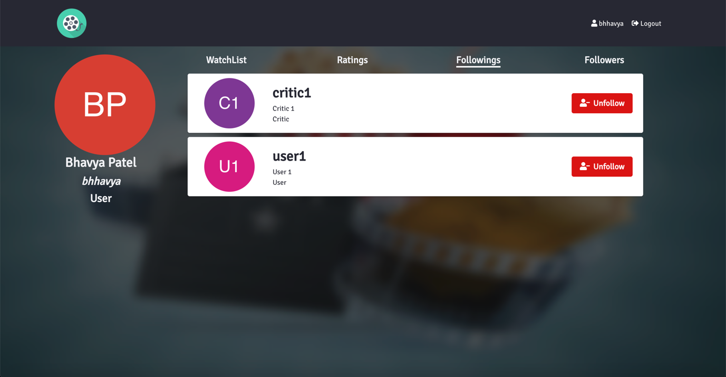

**Search users**

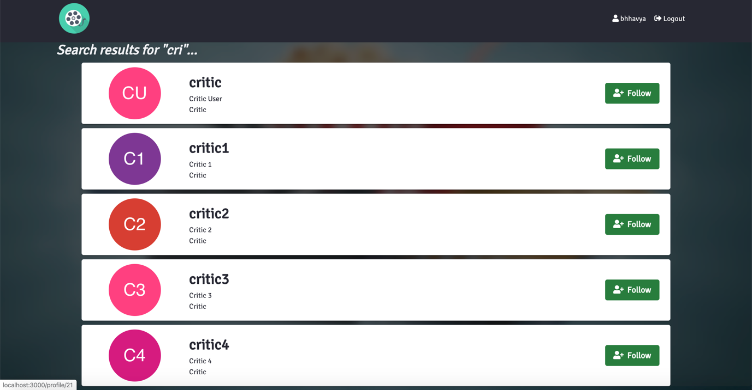

**Unauthorized access response**

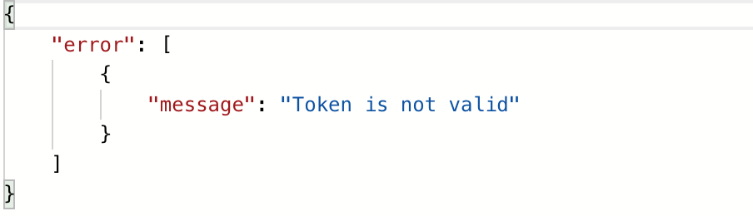

**CONTROLLERS**

1. **Auth Controller**

package com.me.controller;

import com.me.config.JwtTokenUtil;

import com.me.dao.AuthDAO;

import com.me.exception.UserException;

import com.me.pojo.User;

import com.me.response.Errors;

import com.me.response.JwtResponse;

import com.me.response.Message;

import java.util.ArrayList;

import java.util.List;

import javax.servlet.http.HttpServletRequest;

import org.springframework.beans.factory.annotation.Autowired;

import org.springframework.beans.factory.annotation.Qualifier;

import org.springframework.http.HttpStatus;

import org.springframework.http.ResponseEntity;

import org.springframework.web.bind.annotation.RequestBody;

import org.springframework.web.bind.annotation.RequestMapping;

import org.springframework.web.bind.annotation.RequestMethod;

import org.springframework.web.bind.annotation.RestController;

/**

*

* @author bhaVYa

*/

@RestController

@RequestMapping("/api/auth")

public class AuthController {

@Autowired

@Qualifier("authDao")

AuthDAO authDao;

@Autowired

@Qualifier("jwtTokenUtil")

private JwtTokenUtil jwtTokenUtil;

// User Login and return token

// access: private

@RequestMapping(value = "/authenticate", method = RequestMethod.POST, consumes="application/json")

public ResponseEntity<Object> createAuthenticationToken(@RequestBody User u) throws Exception {

try {

User user = authDao.authenticate(u.getUserName(), u.getPassword());

final String token = jwtTokenUtil.generateToken(user);

return new ResponseEntity<>(new JwtResponse(token), HttpStatus.OK);

} catch (UserException e) {

List<Message> errors = new ArrayList<>();

errors.add(new Message(e.getMessage()));

return new ResponseEntity<>(new Errors(errors), HttpStatus.BAD_REQUEST);

}

}

// Getting user details from token

// access: private

@RequestMapping(value = "/getUserDetails", method = RequestMethod.GET)

public ResponseEntity<Object> getUserDetails(HttpServletRequest request) throws Exception {

try {

User user = (User) request.getAttribute("user");

return new ResponseEntity<>(user, HttpStatus.OK);

} catch (Exception e) {

List<Message> errors = new ArrayList<>();

errors.add(new Message(e.getMessage()));

return new ResponseEntity<>(new Errors(errors), HttpStatus.BAD_REQUEST);

}

}

}

1. **User Controller**

package com.me.controller;

import com.me.config.JwtTokenUtil;

import com.me.dao.UserDAO;

import com.me.exception.UserException;

import com.me.pojo.User;

import com.me.response.Errors;

import com.me.response.JwtResponse;

import com.me.response.Message;

import com.me.validator.UserValidator;

import java.util.ArrayList;

import java.util.List;

import java.util.Map;

import java.util.Set;

import javax.servlet.http.HttpServletRequest;

import org.json.JSONObject;

import org.springframework.beans.factory.annotation.Autowired;

import org.springframework.beans.factory.annotation.Qualifier;

import org.springframework.http.HttpHeaders;

import org.springframework.http.HttpStatus;

import org.springframework.http.ResponseEntity;

import org.springframework.validation.BindingResult;

import org.springframework.web.bind.WebDataBinder;

import org.springframework.web.bind.annotation.InitBinder;

import org.springframework.web.bind.annotation.PathVariable;

import org.springframework.web.bind.annotation.RequestBody;

import org.springframework.web.bind.annotation.RequestHeader;

import org.springframework.web.bind.annotation.RequestMapping;

import org.springframework.web.bind.annotation.RequestMethod;

import org.springframework.web.bind.annotation.RestController;

/**

*

* @author bhaVYa

*/

@RestController

@RequestMapping("/api")

public class UserController {

@Autowired

@Qualifier("userDao")

UserDAO userDao;

@Autowired

@Qualifier("userValidator")

UserValidator validator;

@Autowired

@Qualifier("jwtTokenUtil")

private JwtTokenUtil jwtTokenUtil;

@InitBinder("user")

private void initBinder(WebDataBinder binder) {

binder.setValidator(validator);

}

// User registeration

@RequestMapping(value = "/auth/register",

method = RequestMethod.POST,

produces = "application/json")

public ResponseEntity<Object> register(@RequestBody User user, BindingResult result) throws Exception {

// Validting fields in form

validator.validate(user, result);

if (result.hasErrors()) {

List<Message> errors = new ArrayList<>();

result.getFieldErrors().stream()

.forEach(action -> errors.add(new Message(action.getDefaultMessage())));

return new ResponseEntity<>(new Errors(errors), HttpStatus.BAD_REQUEST);

}

try {

User u = userDao.register(user);

// Generating token from User object

final String token = jwtTokenUtil.generateToken(u);

return new ResponseEntity<>(new JwtResponse(token), HttpStatus.OK);

} catch (UserException e) {

List<Message> errors = new ArrayList<>();

errors.add(new Message(e.getMessage()));

return new ResponseEntity<>(new Errors(errors), HttpStatus.BAD_REQUEST);

}

}

// Get user details along with following details in term of requesting user

@RequestMapping(value = "/users/{userId}",

method = RequestMethod.GET,

produces = "application/json")

public ResponseEntity<Object> getUser(@PathVariable String userId, @RequestHeader HttpHeaders headers) throws Exception {

try {

String requestingUser = "";

if (headers.get("x-auth-token") == null) {

requestingUser += "guest";

} else {

String token = headers.get("x-auth-token").get(0);

requestingUser += jwtTokenUtil.getUserIdFromToken(token.substring(7));

}

User user = userDao.getUser(userId);

JSONObject userJson = new JSONObject();

userJson.put("userId", user.getUserId());

userJson.put("userName", user.getUserName());

userJson.put("firstName", user.getFirstName());

userJson.put("lastName", user.getLastName());

userJson.put("userRole", user.getUserRole());

if (!requestingUser.equals("guest")) {

User reqUser = userDao.getUser(requestingUser);

if (reqUser.getFollowings().contains(user)) {

userJson.put("isFollowing", true);

} else {

userJson.put("isFollowing", false);

}

} else {

userJson.put("isFollowing", false);

}

return new ResponseEntity<>(userJson.toMap(), HttpStatus.OK);

} catch (Exception e) {

List<Message> errors = new ArrayList<>();

errors.add(new Message(e.getMessage()));

return new ResponseEntity<>(new Errors(errors), HttpStatus.BAD_REQUEST);

}

}

// Search Users

@RequestMapping(value = "/users/search/{userName}",

method = RequestMethod.GET,

produces = "application/json")

public ResponseEntity<Object> searchUsers(@PathVariable String userName) throws Exception {

try {

List<User> users = userDao.search(userName);

return new ResponseEntity<>(users, HttpStatus.OK);

} catch(UserException e) {

List<Message> errors = new ArrayList<>();

errors.add(new Message(e.getMessage()));

return new ResponseEntity<>(new Errors(errors), HttpStatus.BAD_REQUEST);

}

}

// Follow users

// Access: private

@RequestMapping(value = "/users/follow/{followingId}",

method = RequestMethod.POST,

produces = "application/json")

public ResponseEntity<Object> follow(@PathVariable String followingId, HttpServletRequest request) throws Exception {

try {

User user = (User) request.getAttribute("user");

userDao.follow(user, followingId);

return new ResponseEntity<>(new Message("Followed Successfully"), HttpStatus.OK);

} catch (UserException e) {

List<Message> errors = new ArrayList<>();

errors.add(new Message(e.getMessage()));

return new ResponseEntity<>(new Errors(errors), HttpStatus.BAD_REQUEST);

}

}

// Unfollow users

// Access: private

@RequestMapping(value = "/users/unfollow/{unfollowingId}",

method = RequestMethod.POST,

produces = "application/json")

public ResponseEntity<Object> unfollow(@PathVariable String unfollowingId, HttpServletRequest request) throws Exception {

try {

User user = (User) request.getAttribute("user");

userDao.unfollow(user, unfollowingId);

return new ResponseEntity<>(new Message("Unfollowed Successfully"), HttpStatus.OK);

} catch (UserException e) {

System.out.println("UNFOLLOW1"+e.getMessage());

List<Message> errors = new ArrayList<>();

errors.add(new Message(e.getMessage()));

return new ResponseEntity<>(new Errors(errors), HttpStatus.BAD_REQUEST);

}

}

// Get followings list

@RequestMapping(value = "/users/followings/{id}",

method = RequestMethod.GET,

produces = "application/json")

public ResponseEntity<Object> getFollowings(@PathVariable String id, @RequestHeader HttpHeaders headers) throws Exception {

try {

String requestingUser = "";

if (headers.get("x-auth-token") == null) {

requestingUser += "guest";

} else {

String token = headers.get("x-auth-token").get(0);

requestingUser += jwtTokenUtil.getUserIdFromToken(token.substring(7));

}

Set<User> followings = userDao.getFollowings(id);

User reqUser = null;

if (!requestingUser.equals("guest")) {

reqUser = userDao.getUser(requestingUser);

}

List<Map<String, Object>> list = new ArrayList<>();

for(User u: followings) {

JSONObject userJson = new JSONObject();

userJson.put("userId", u.getUserId());

userJson.put("userName", u.getUserName());

userJson.put("firstName", u.getFirstName());

userJson.put("lastName", u.getLastName());

userJson.put("userRole", u.getUserRole());

if(!requestingUser.equals("guest")) {

if(reqUser.getFollowings().contains(u))

userJson.put("isFollowing", true);

else

userJson.put("isFollowing", false);

} else {

userJson.put("isFollowing", false);

}

list.add(userJson.toMap());

}

return new ResponseEntity<>(list, HttpStatus.OK);

} catch (Exception e) {

List<Message> errors = new ArrayList<>();

errors.add(new Message(e.getMessage()));

return new ResponseEntity<>(new Errors(errors), HttpStatus.BAD_REQUEST);

}

}

// Get followers list

@RequestMapping(value = "/users/followers/{id}",

method = RequestMethod.GET,

produces = "application/json")

public ResponseEntity<Object> getFollowers(@PathVariable String id, @RequestHeader HttpHeaders headers) throws Exception {

try {

String requestingUser = "";

if (headers.get("x-auth-token") == null) {

requestingUser += "guest";

} else {

String token = headers.get("x-auth-token").get(0);

requestingUser += jwtTokenUtil.getUserIdFromToken(token.substring(7));

}

Set<User> followers = userDao.getFollowers(id);

User reqUser = null;

if (!requestingUser.equals("guest")) {

reqUser = userDao.getUser(requestingUser);

}

List<Map<String, Object>> list = new ArrayList<>();

for(User u: followers) {

JSONObject userJson = new JSONObject();

userJson.put("userId", u.getUserId());

userJson.put("userName", u.getUserName());

userJson.put("firstName", u.getFirstName());

userJson.put("lastName", u.getLastName());

userJson.put("userRole", u.getUserRole());

if(!requestingUser.equals("guest")) {

if(reqUser.getFollowings().contains(u))

userJson.put("isFollowing", true);

else

userJson.put("isFollowing", false);

} else {

userJson.put("isFollowing", false);

}

list.add(userJson.toMap());

}

return new ResponseEntity<>(list, HttpStatus.OK);

} catch (Exception e) {

List<Message> errors = new ArrayList<>();

errors.add(new Message(e.getMessage()));

return new ResponseEntity<>(new Errors(errors), HttpStatus.BAD_REQUEST);

}

}

}

1. **Movie Controller**

package com.me.controller;

import com.me.dao.MovieDAO;

import com.me.exception.MovieException;

import com.me.pojo.Movie;

import com.me.pojo.Reviews;

import com.me.pojo.User;

import com.me.pojo.UserRole;

import com.me.response.Errors;

import com.me.response.Message;

import java.util.ArrayList;

import java.util.List;

import java.util.Set;

import javax.servlet.http.HttpServletRequest;

import org.json.JSONObject;

import org.springframework.beans.factory.annotation.Autowired;

import org.springframework.beans.factory.annotation.Qualifier;

import org.springframework.http.HttpStatus;

import org.springframework.http.ResponseEntity;

import org.springframework.web.bind.annotation.PathVariable;

import org.springframework.web.bind.annotation.RequestBody;

import org.springframework.web.bind.annotation.RequestMapping;

import org.springframework.web.bind.annotation.RequestMethod;

import org.springframework.web.bind.annotation.RestController;

/**

*

* @author bhaVYa

*/

@RestController

@RequestMapping("/api")

public class MovieController {

@Autowired

@Qualifier("movieDao")

MovieDAO movieDao;

@RequestMapping(value = "/movies/watchlist/add",

method = RequestMethod.POST,

produces = "application/json")

public ResponseEntity<Object> addToWatchList(@RequestBody Movie movie, HttpServletRequest request) throws Exception {

User user = null;

try {

user = (User) request.getAttribute("user");

movieDao.addToWatchList(user, movie);

return new ResponseEntity<>(new Message("Movie added to watchlist"), HttpStatus.OK);

} catch (MovieException e) {

List<Message> errors = new ArrayList<>();

errors.add(new Message(e.getMessage()));

return new ResponseEntity<>(new Errors(errors), HttpStatus.BAD_REQUEST);

}

}

@RequestMapping(value = "/movies/watchlist/remove",

method = RequestMethod.POST,

produces = "application/json")

public ResponseEntity<Object> removeFromWatchList(@RequestBody Movie movie, HttpServletRequest request) throws Exception {

User user = null;

try {

user = (User) request.getAttribute("user");

movieDao.removeFromWatchList(user, movie);

return new ResponseEntity<>(new Message("Movie removed from watchlist"), HttpStatus.OK);

} catch (MovieException e) {

List<Message> errors = new ArrayList<>();

errors.add(new Message(e.getMessage()));

return new ResponseEntity<>(new Errors(errors), HttpStatus.BAD_REQUEST);

}

}

@RequestMapping(value = "/movies/watchlist",

method = RequestMethod.POST,

produces = "application/json")

public ResponseEntity<Object> isWatchList(@RequestBody Movie movie, HttpServletRequest request) throws Exception {

User user = null;

try {

user = (User) request.getAttribute("user");

boolean isWatchList;

if (user == null) {

isWatchList = false;

} else {

isWatchList = movieDao.isWatchList(movie, user);

}

return new ResponseEntity<>(new Message(String.valueOf(isWatchList)), HttpStatus.OK);

} catch (Exception e) {

List<Message> errors = new ArrayList<>();

errors.add(new Message(e.getMessage()));

return new ResponseEntity<>(new Errors(errors), HttpStatus.BAD_REQUEST);

}

}

@RequestMapping(value = "/movies/watchlist/{userId}",

method = RequestMethod.GET,

produces = "application/json")

public ResponseEntity<Object> getWatchList(@PathVariable String userId) {

try {

Set<Movie> watchlist = movieDao.getWatchList(userId);

return new ResponseEntity<>(watchlist, HttpStatus.OK);

} catch (MovieException e) {

List<Message> errors = new ArrayList<>();

errors.add(new Message(e.getMessage()));

return new ResponseEntity<>(new Errors(errors), HttpStatus.BAD_REQUEST);

}

}

@RequestMapping(value = "/movies/ratings/add/{rating}",

method = RequestMethod.POST,

produces = "application/json")

public ResponseEntity<Object> addRatings(@PathVariable String rating, @RequestBody Movie movie, HttpServletRequest request) {

try {

double r = Double.parseDouble(rating);

if (r < 0 || r > 10) {

throw new MovieException("Rating should be in range of 0 to 10");

}

User user = (User) request.getAttribute("user");

movieDao.addRatings(movie, user, r);

return new ResponseEntity<>(new Message("Ratings added"), HttpStatus.OK);

} catch (MovieException e) {

List<Message> errors = new ArrayList<>();

errors.add(new Message(e.getMessage()));

return new ResponseEntity<>(new Errors(errors), HttpStatus.BAD_REQUEST);

} catch (NumberFormatException e) {

List<Message> errors = new ArrayList<>();

errors.add(new Message("Invalid ratings"));

return new ResponseEntity<>(new Errors(errors), HttpStatus.BAD_REQUEST);

}

}

@RequestMapping(value = "/movies/ratings/update/{rating}",

method = RequestMethod.POST,

produces = "application/json")

public ResponseEntity<Object> updateRatings(@PathVariable String rating, @RequestBody Movie movie, HttpServletRequest request) {

try {

double r = Double.parseDouble(rating);

if (r < 0 || r > 10) {

throw new MovieException("Rating should be in range of 0 to 10");

}

User user = (User) request.getAttribute("user");

movieDao.updateRatings(movie, user, r);

return new ResponseEntity<>(new Message("Ratings updated"), HttpStatus.OK);

} catch (MovieException e) {

List<Message> errors = new ArrayList<>();

errors.add(new Message(e.getMessage()));

return new ResponseEntity<>(new Errors(errors), HttpStatus.BAD_REQUEST);

} catch (NumberFormatException e) {

List<Message> errors = new ArrayList<>();

errors.add(new Message("Invalid ratings"));

return new ResponseEntity<>(new Errors(errors), HttpStatus.BAD_REQUEST);

}

}

@RequestMapping(value = "/movies/ratings/delete",

method = RequestMethod.POST,

produces = "application/json")

public ResponseEntity<Object> deleteRatings(@RequestBody Movie movie, HttpServletRequest request) {

try {

User user = (User) request.getAttribute("user");

movieDao.deleteRatings(movie, user);

return new ResponseEntity<>(new Message("Ratings deleted"), HttpStatus.OK);

} catch (MovieException e) {

List<Message> errors = new ArrayList<>();

errors.add(new Message(e.getMessage()));

return new ResponseEntity<>(new Errors(errors), HttpStatus.BAD_REQUEST);

}

}

@RequestMapping(value = "/movies/ratings/get/{movieId}",

method = RequestMethod.GET,

produces = "application/json")

public ResponseEntity<Object> getAvgRatings(@PathVariable String movieId, HttpServletRequest request) {

try {

double avgRatings = movieDao.getAvgRatings(movieId);

return new ResponseEntity<>(new Message(String.valueOf(avgRatings)), HttpStatus.OK);

} catch (MovieException e) {

List<Message> errors = new ArrayList<>();

errors.add(new Message(e.getMessage()));

return new ResponseEntity<>(new Errors(errors), HttpStatus.BAD_REQUEST);

}

}

@RequestMapping(value = "/movies/ratings/users/get/{movieId}",

method = RequestMethod.GET,

produces = "application/json")

public ResponseEntity<Object> getUserRatingsForMovie(@PathVariable String movieId, HttpServletRequest request) {

try {

User user = (User) request.getAttribute("user");

JSONObject ratings = movieDao.getUserRatingsForMovie(movieId, user);

return new ResponseEntity<>(ratings.toMap(), HttpStatus.OK);

} catch (MovieException e) {

List<Message> errors = new ArrayList<>();

errors.add(new Message(e.getMessage()));

return new ResponseEntity<>(new Errors(errors), HttpStatus.BAD_REQUEST);

}

}

@RequestMapping(value = "/movies/ratings/users/{userId}",

method = RequestMethod.GET,

produces = "application/json")

public ResponseEntity<Object> getUserRatings(@PathVariable String userId, HttpServletRequest request) {

try {

// User user = (User) request.getAttribute("user");

List<Object> ratings = movieDao.getUserRatings(userId);

return new ResponseEntity<>(ratings, HttpStatus.OK);

} catch (MovieException e) {

List<Message> errors = new ArrayList<>();

errors.add(new Message(e.getMessage()));

return new ResponseEntity<>(new Errors(errors), HttpStatus.BAD_REQUEST);

}

}

// Add Review for Movie

@RequestMapping(value = "/movies/reviews/add",

method = RequestMethod.POST,

produces = "application/json")

public ResponseEntity<Object> addReview(@RequestBody String body, HttpServletRequest request) {

try {

User user = (User) request.getAttribute("user");

if (user.getUserRole() == UserRole.User) {

throw new MovieException("User is unauthorized");

}

JSONObject json = new JSONObject(body);

if (json.getString("review").equals("")) {

throw new MovieException("Review is empty text");

}

Movie m = new Movie();

m.setMovieId(json.getInt("movieId"));

m.setMovieName(json.getString("movieName"));

m.setMovieImage(json.getString("movieImage"));

Reviews r =movieDao.addReview(user, m, json.getString("review"));

return new ResponseEntity<>(r, HttpStatus.OK);

} catch (MovieException e) {

List<Message> errors = new ArrayList<>();

errors.add(new Message(e.getMessage()));

return new ResponseEntity<>(new Errors(errors), HttpStatus.BAD_REQUEST);

}

}

// Update Review for Movie

@RequestMapping(value = "/movies/reviews/update",

method = RequestMethod.POST,

produces = "application/json")

public ResponseEntity<Object> updateReview(@RequestBody String body, HttpServletRequest request) {

try {

User user = (User) request.getAttribute("user");

if (user.getUserRole() == UserRole.User) {

throw new MovieException("User is unauthorized");

}

JSONObject json = new JSONObject(body);

if (json.getString("review").equals("")) {

throw new MovieException("Review is empty text");

}

movieDao.updateReview(user, json.getInt("reviewId"), json.getString("review"));

return new ResponseEntity<>(new Message("Review updated"), HttpStatus.OK);

} catch (MovieException e) {

List<Message> errors = new ArrayList<>();

errors.add(new Message(e.getMessage()));

return new ResponseEntity<>(new Errors(errors), HttpStatus.BAD_REQUEST);

}

}

// Update Review for Movie

@RequestMapping(value = "/movies/reviews/delete",

method = RequestMethod.POST,

produces = "application/json")

public ResponseEntity<Object> deleteReview(@RequestBody String body, HttpServletRequest request) {

try {

User user = (User) request.getAttribute("user");

if (user.getUserRole() == UserRole.User) {

throw new MovieException("User is unauthorized");

}

JSONObject json = new JSONObject(body);

movieDao.deleteReview(user, json.getInt("reviewId"));

return new ResponseEntity<>(new Message("Review deleted"), HttpStatus.OK);

} catch (MovieException e) {

List<Message> errors = new ArrayList<>();

errors.add(new Message(e.getMessage()));

return new ResponseEntity<>(new Errors(errors), HttpStatus.BAD_REQUEST);

}

}

// Get Review for Movie

@RequestMapping(value = "/movies/reviews/{movieId}",

method = RequestMethod.GET,

produces = "application/json")

public ResponseEntity<Object> getReviewsForMovie(@PathVariable String movieId, HttpServletRequest request) {

try {

List<Reviews> list = movieDao.getReviewsForMovie(movieId);

return new ResponseEntity<>(list, HttpStatus.OK);

} catch (MovieException e) {

List<Message> errors = new ArrayList<>();

errors.add(new Message(e.getMessage()));

return new ResponseEntity<>(new Errors(errors), HttpStatus.BAD_REQUEST);

}

}

// Get Review for User

@RequestMapping(value = "/movies/reviews/users/{userId}",

method = RequestMethod.GET,

produces = "application/json")

public ResponseEntity<Object> getReviewsForUser(@PathVariable String userId, HttpServletRequest request) {

try {

List<Reviews> list = movieDao.getReviewsForUser(userId);

return new ResponseEntity<>(list, HttpStatus.OK);

} catch (MovieException e) {

List<Message> errors = new ArrayList<>();

errors.add(new Message(e.getMessage()));

return new ResponseEntity<>(new Errors(errors), HttpStatus.BAD_REQUEST);

}

}

}

1. **Error Controller**

package com.me.controller;

import javax.servlet.http.HttpServletRequest;

import org.json.JSONObject;

import org.springframework.http.HttpStatus;

import org.springframework.http.ResponseEntity;

import org.springframework.web.bind.annotation.RequestMapping;

import org.springframework.web.bind.annotation.RequestMethod;

import org.springframework.web.bind.annotation.RestController;

/**

*

* @author bhaVYa

*/

@RestController

@RequestMapping("/api")

public class ErrorController {

@RequestMapping(value = "/error/404",

method = RequestMethod.GET,

produces = "application/json")

public ResponseEntity<Object> error404(HttpServletRequest request) throws Exception {

JSONObject json = new JSONObject();

json.put("error", "Page not Found");

return new ResponseEntity<>(json.toMap(), HttpStatus.NOT_FOUND);

}

@RequestMapping(value = "/error/405",

method = RequestMethod.GET,

produces = "application/json")

public ResponseEntity<Object> error405(HttpServletRequest request) throws Exception {

JSONObject json = new JSONObject();

json.put("error", "Method not allowed");

return new ResponseEntity<>(json.toMap(), HttpStatus.NOT_FOUND);

}

}